Galactic/Stellar Database

**Part 1 Doman Description:**

My Project is a Galactic/Stellar database that contains 4 tables, galaxies, stars, galaxy_nucleus, and asteroids, my tables are defined as follows:

Galaxies each have a glactic nucleus and each star has a number of planets that orbit it. Each planet has a many to many relationship with planets as planets disfigure asteroids and asteroids disfigure planets.

**Part 2: ER diagram:**

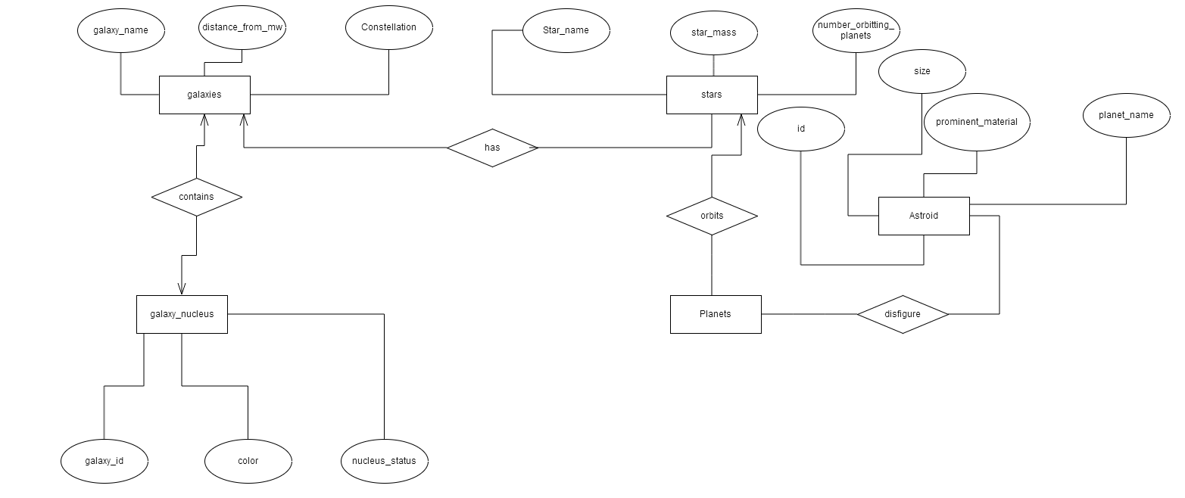

**Part 4 Normal Forms**

Functional Dependencides

FD#1:

*Planet_name->star_id, planetary_mass, planet_volume, planet_radius, star_distance

*Boyce Codd normal Form? Yes because planet_name is a key within the Planets relation which is declared by calling unique within the Planets relation. Also, Planet_name functionaly determines all attributes within the planet relation.

*4th normal form? Yes, since the left side is a key and the previous functional dependecy also implies the multivalued dependency Planet_name ->>star_id,Planet_mass,planet_volume,planet_radius,star_distance

*3rd normal_form? Yes, since planet_name is a key, which is also a super-key and the previous functional dependency is a non-trivial FD.

FD#2:

*star_name->num_planets, star_mass

*Boyce Codd normal Form? Yes becaue star_name is a primary key within the stars relation which also means that star_name functionally determines all attributes in the stars relation

*4th normal form? Yes, since the left side is a key, which also implies the multivalued dependency star_name ->>num_planets, star_mass

3rd normal_form? Yes, since star_name is a primary key and the dependency is a non-trivial FD

**Application/Use Cases:**

Possible Applications that can be run on the database are graphical star/planet finding applications that can be used to view and learn about the various stars and planets through a user friendly experience.

**Data Mining Opportunities:**

Some data mining opportunities include looking at the stars and seeing if there is a correlation between the size of the stars and the size of the planets that orbit it. It would be a supervised learning example because there is an output that you are striving for with your algorithm and as more planetary/star information is discovered the data can update.

**Future Work:**

Some future work that can be done on the project are adding some more advanced queries/algroithms that can be used to correlate the data in more relevant ways. Also, the exoplanet archive, the source of alot of my data has an API that can be used to manipulate their data. By learning that structure I can retrieve alot of my data faster than I was able to in the past.6y